NAME____________________________LAB MEETING DAY/TIME______________

Lab 7: Geologic Maps

In this lab you will examine geologic maps, and the ways they help us understand the features of a landscape. You will be completing Exercise 13 in your lab manual for this lab.

# **Exercise 13, Part A**

**Question 1: Follow the directions in the part text to draw the contact and color the two formations on the map below.**

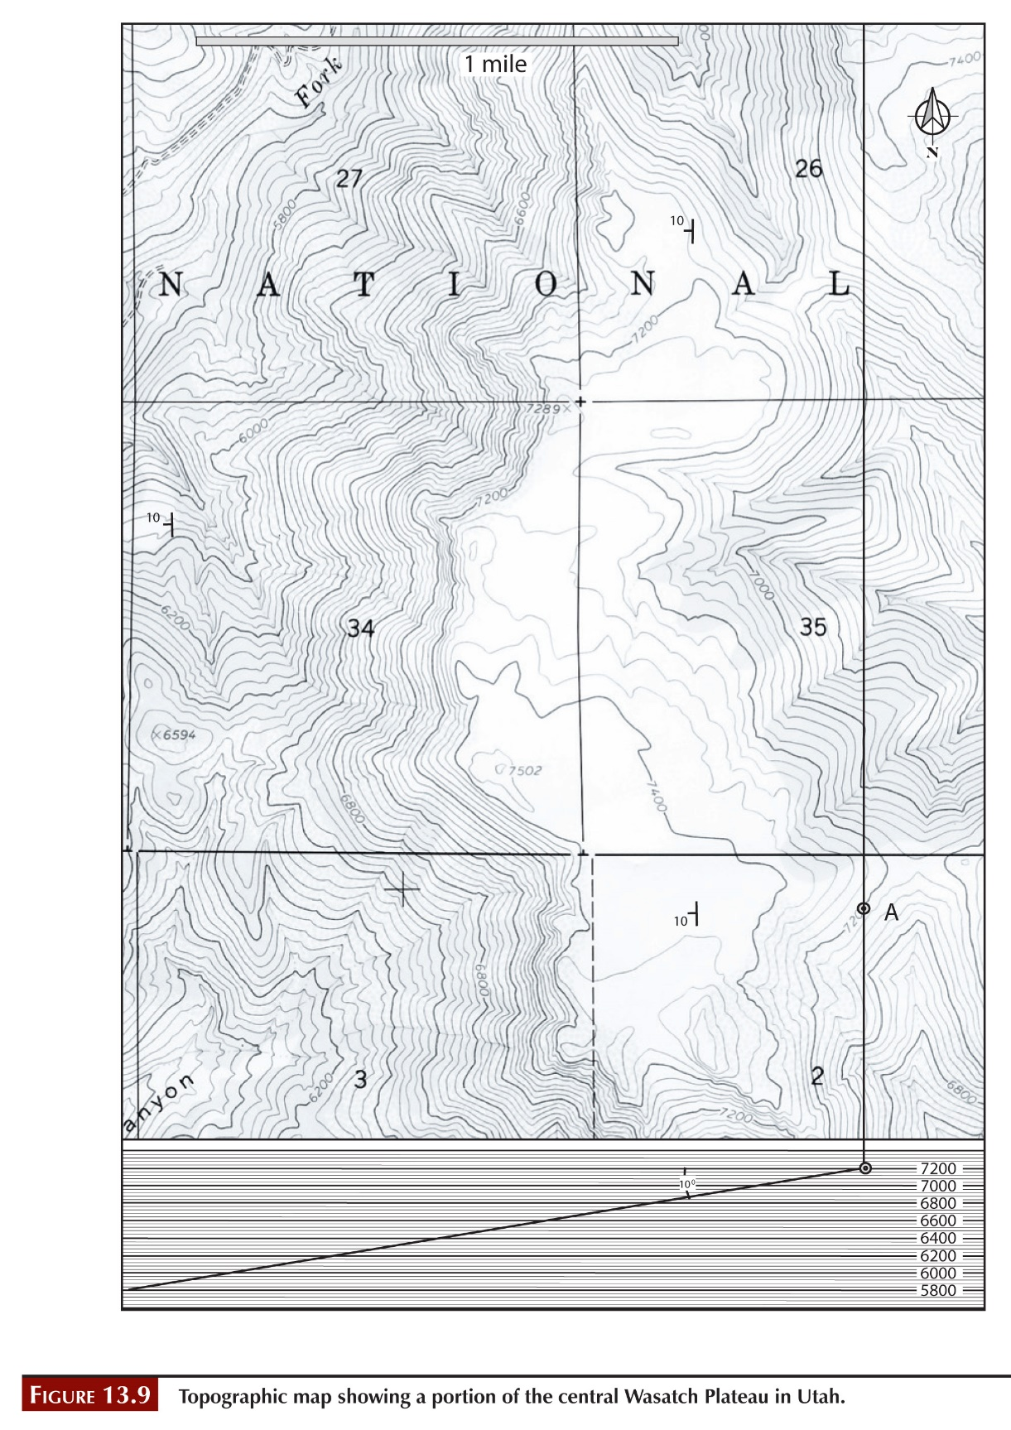

**Question 2:**

# **Exercise 13, Part B**

**Question 1: Follow the directions in this question to complete the geologic cross section below. The easiest way to do this will be to fold this page and lie it along line A-A’ on the map on page 204 of your lab manual.**

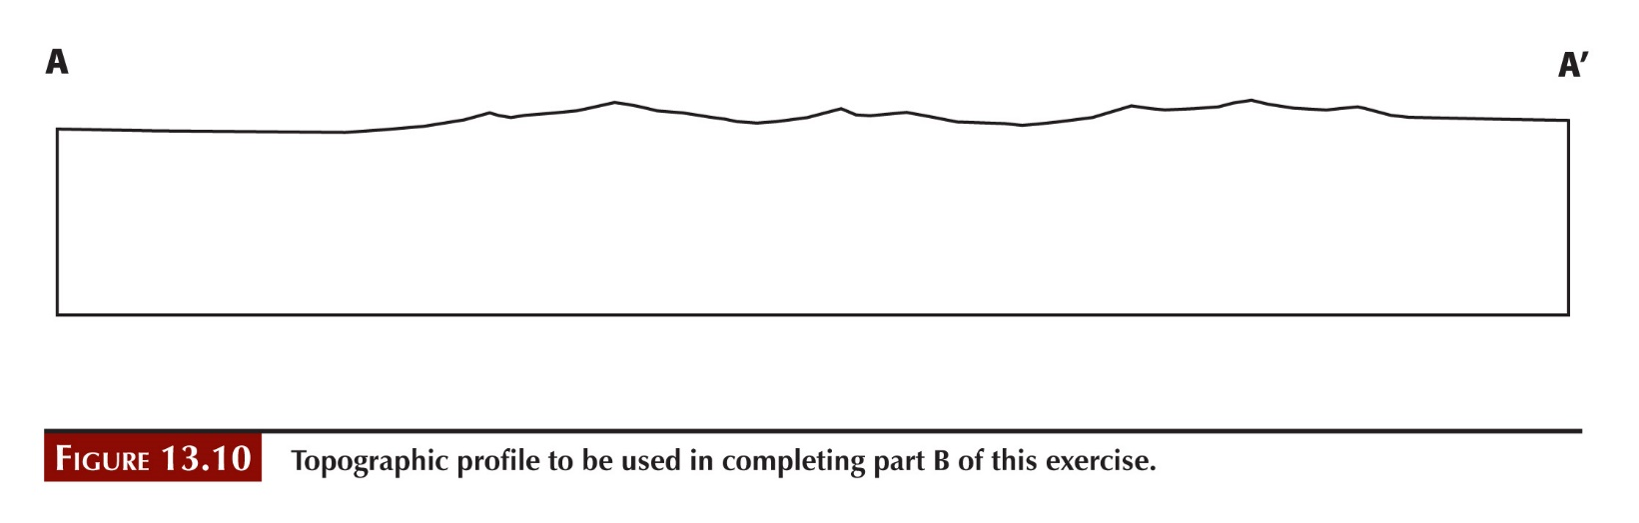

**Question 2:**

**Question 3:**

**Question 4:**

**Question 5:**

# **Exercise 13, Part C**

**Question 1: Follow the directions in this question to complete the geologic cross section below. The easiest way to do this will be to fold this page and lie it along line A-A’ on the map on page 214 of your lab manual.**

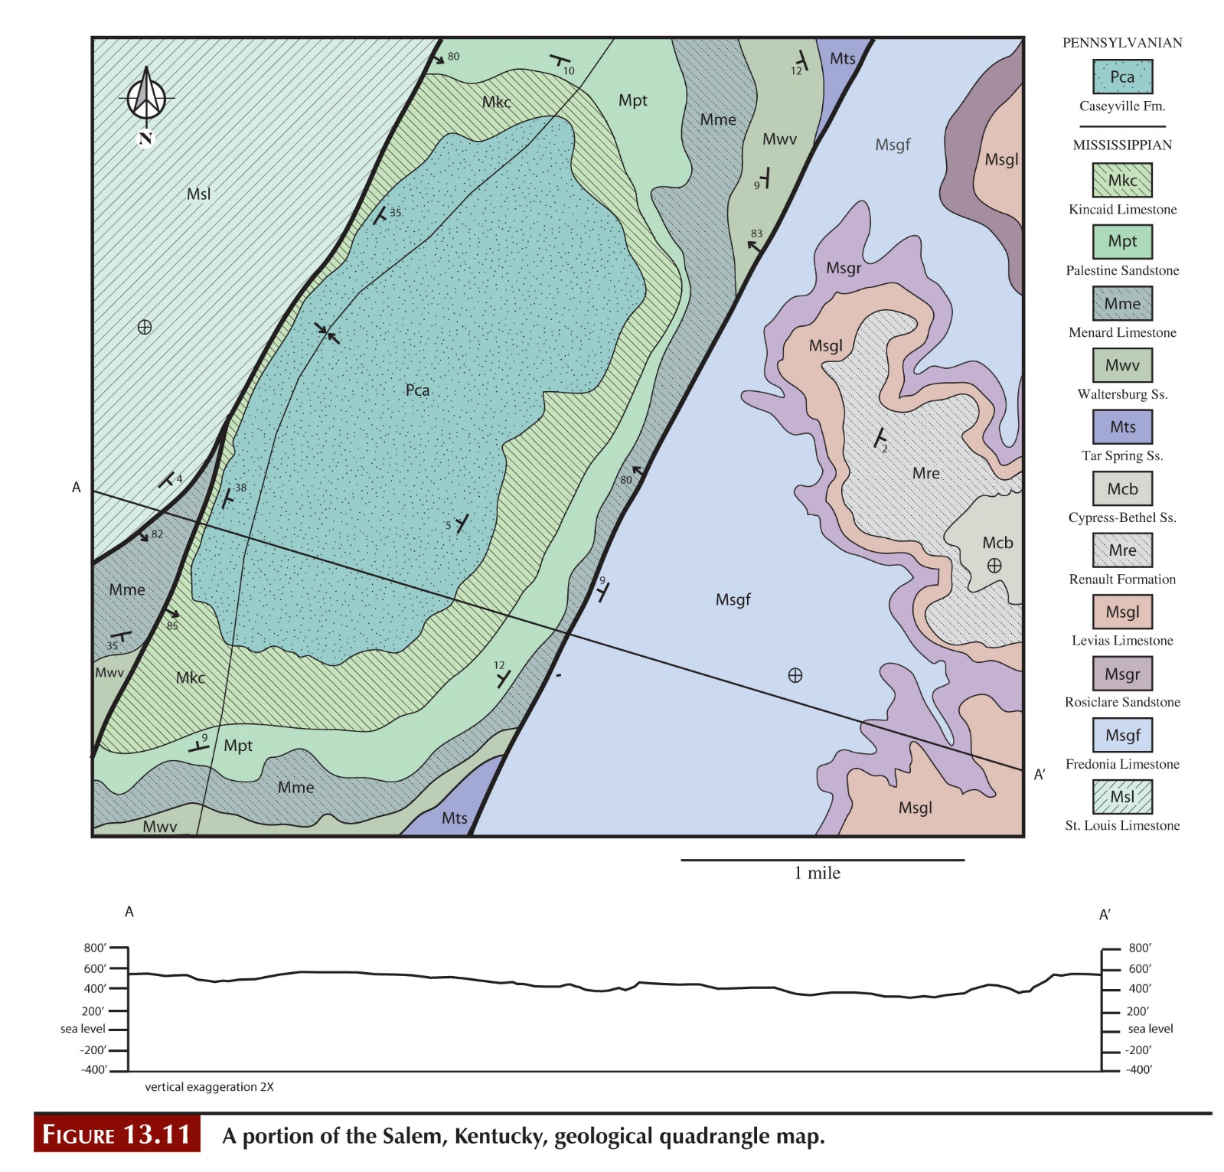

**Question 2: Note that “geologic systems” refer to the rock units on the map.**

**Question 3:**

**Question 4:**

# **Exercise 13, Part D**

**Question 1: Note that “geological systems” is referring to the rock units present.**

**Question 2:**

**Question 3: Note that “nature of the contact” is asking for the type of unconformity.**

**Question 4:**

**Question 5:**

**Question 6:**

**Question 7:**

**Question 8:**

**Question 9:**

# **Lab 7 Reflection**

**What are the differences and similarities between geologic maps, topographic profiles, and geologic cross sections?**

**How do you feel about interpreting geologic maps after this lab? What seems easiest? What needs more explanation?**